Grecian Odyssey - $ 6311

https://www.eftours.ca/educational-tour/grecian-odyssey?query=greecian+odyssey

12 days

What is it like to live in a country where classical mythology and ancient history still have a presence in everyday life?
In the capital of Athens, namesake of the goddess Athena, walk in the footsteps of ancient Greeks at the Acropolis - and in the footsteps of current residents in the Plaka district. In Delphi, Epidaurus and Cape Sounion, learn how an old belief in mythological figures still influences medicine, politics and philosophy.
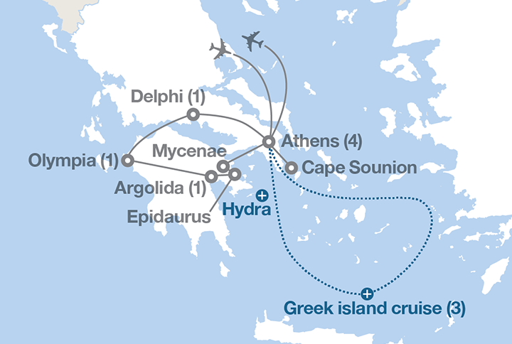
- Day 1: Fly overnight to Greece
- Day 2: Athens
Meet your Tour Director at your destination
- Day 3: Athens
Visit the Temple of Poseidon
Tour Cape Sounion with an expert local guide
Travel via Corinth to Argolida
See the Corinth Canal
- Day 4: Athens
Travel to Olympia via Epidaurus and Mycenae
Tour Epidaurus and Mycenae with an expert local guide
Transfer to Mycenae
Take a guided tour of Mycenae
Participate in a pottery workshop
- Day 5: Athens • Corinth • Argolida
Visit the Archaeological Museum of Olympia
Tour Olympia with an expert local guide
Visit the Museum of Archimedes
Arrive in Patras
Travel to Delphi
- Day 6: Argolida • Epidaurus • Mycenae • Olympia
Take a guided tour of Delphi
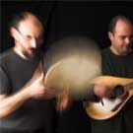
With your expert local guide you will see:
  - Temple of Apollo
  - Delphi Archaeological Museum
Travel to Athens
Add this in-depth excursion: Greek Evening

Greek Evening
- Day 7: Olympia • Delphi
Take a guided tour of Athens
With your expert local guide you will see:
  - Olympic Stadium
  - Syntagma Square
  - Acropolis
Visit the Acropolis:
  - Parthenon
  - Temple of Athena Nike
Visit the Acropolis Museum, home to ancient ruins and prehistoric artefacts.
Take a walking tour of Athens
With your Tour Director you will see:
  - Plaka district
  - Athenian Trilogy
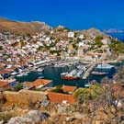
- Day 8: Delphi • Athens
Add this in-depth excursion:

Add 3 more days
- Day 9: Greek Island Cruise
Set sail on your cruise ship for a three-day adventure filled with on-board activities and a three-island shore excursion package. Experience how Turkish, Roman, and Greek influences helped shape the unique blend of cultures you’ll encounter as you explore each coastal town.
- Day 10: Mykonos • Santorini
Included excursion to Oia Village in Santorini
Included shore excursion - Guided walking tour of the Old Town of Mykonos
- Day 11: Cesme, Turkey • Ancient Apehesus
Included shore excursion to Cesme - Guided visit of Ancient Ephesus
- Day 12: Depart for home

